2️⃣6️⃣ HTML URL ENCODING
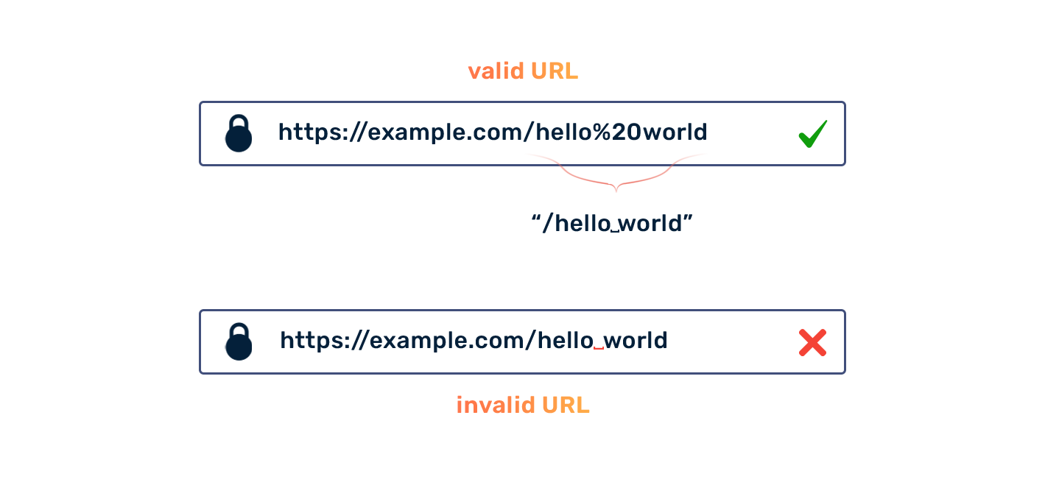
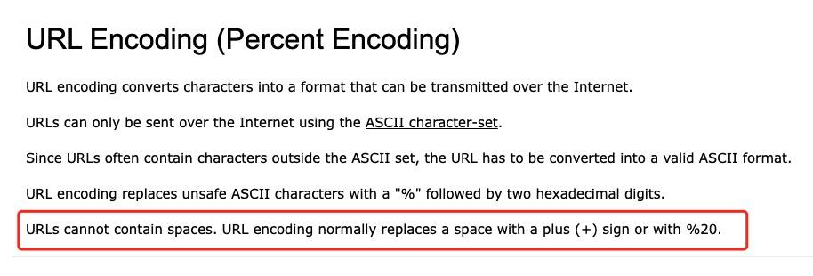
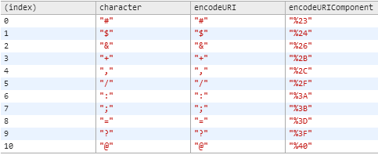
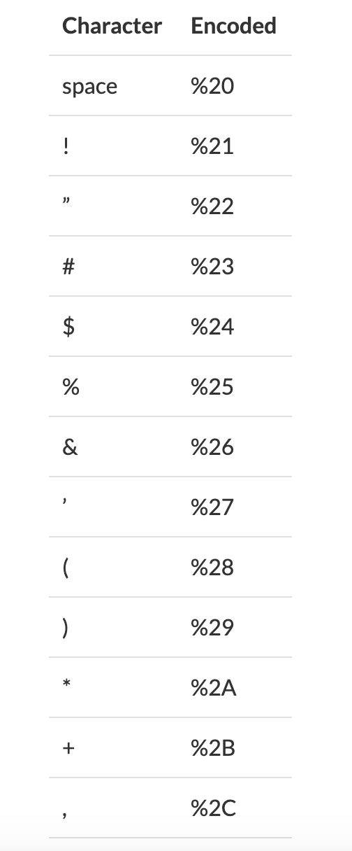
URL encoding is used to convert special characters into a safe format so browsers can understand URLs correctly.

🔹 Why URL Encoding?
URLs cannot contain spaces or special characters.
Example ❌
https://site.com/my file.html
Correct ✅
https://site.com/my%20file.html

🔹 Common Encodings
Character | Encoded
Space | %20
& | %26
= | %3D
? | %3F
📌 Used mainly in:
✔ Query strings
✔ Form submissions
✔ API URLs
📌 Interview Line:
URL encoding ensures data is transmitted safely over HTTP.

2️⃣7️⃣ HTML ACCESSIBILITY (A11Y) ♿
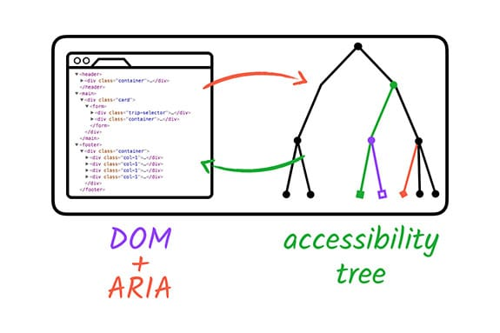
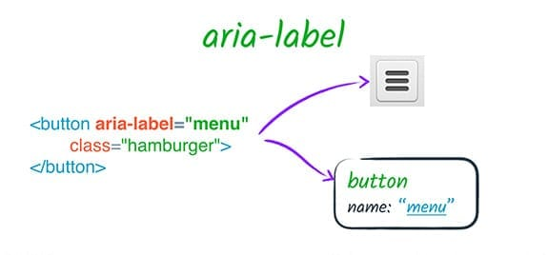
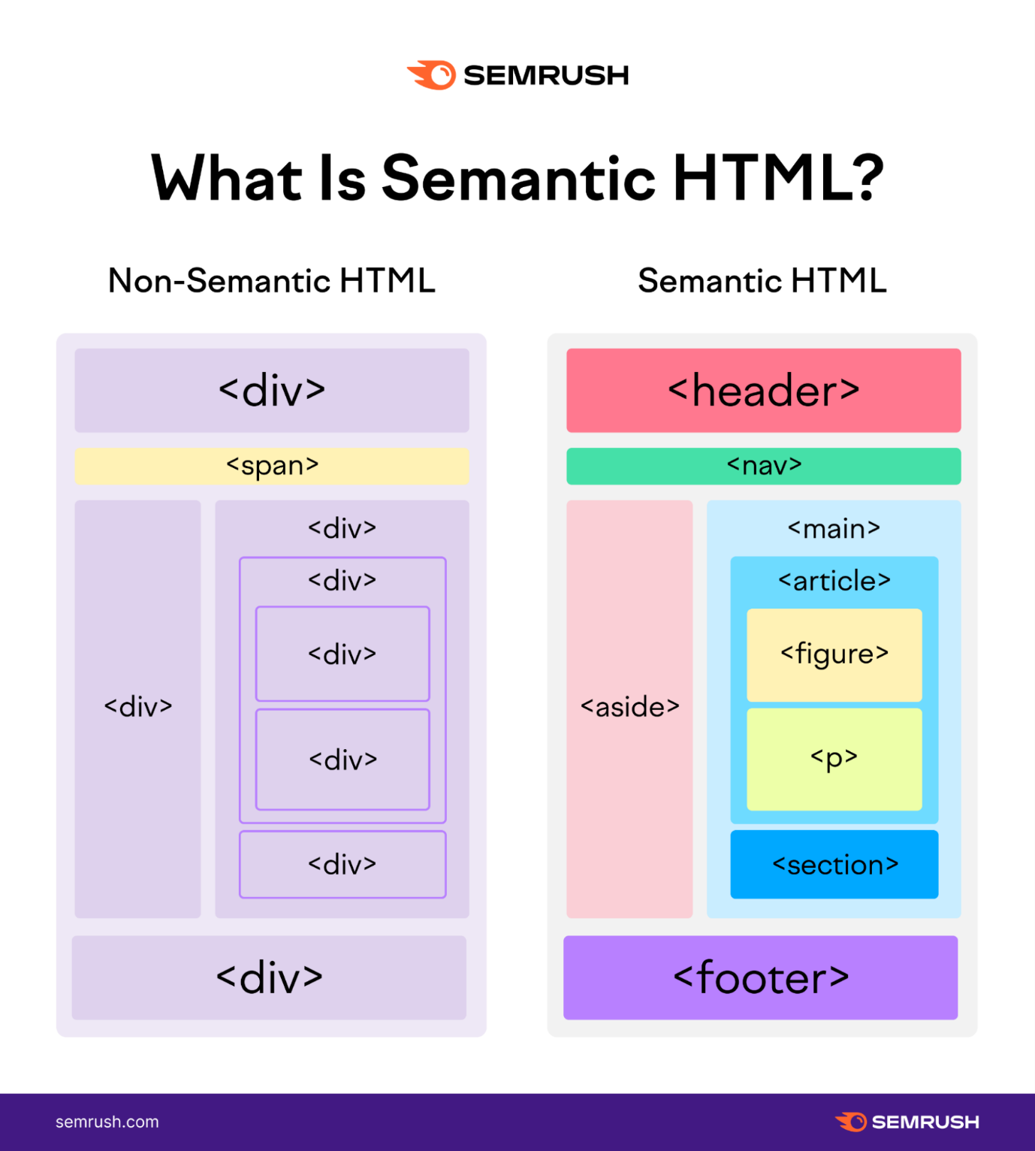
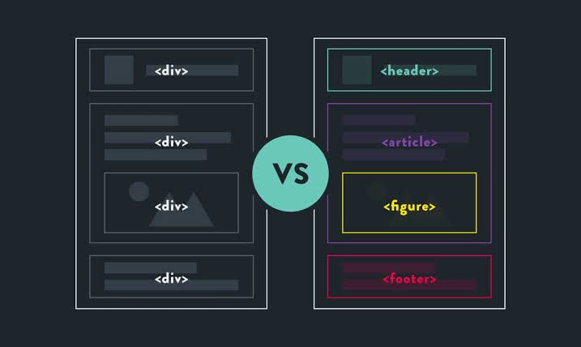
Accessibility ensures websites are usable by people with disabilities.

🔹 alt Attribute
<img src="car.jpg" alt="Red sports car">
✔ Screen readers
✔ SEO
✔ Mandatory 🔥

🔹 aria-label
Provides extra info for screen readers.
<button aria-label="Close menu">X</button>

🔹 role
Defines element purpose.
<div role="navigation"></div>
📌 Use semantic HTML first, ARIA second.

🔹 Semantic HTML
<nav>Menu</nav>
<main>Content</main>
📌 Interview Line:
Accessibility is a legal requirement in many countries.

2️⃣8️⃣ HTML SEO BASICS 🔍
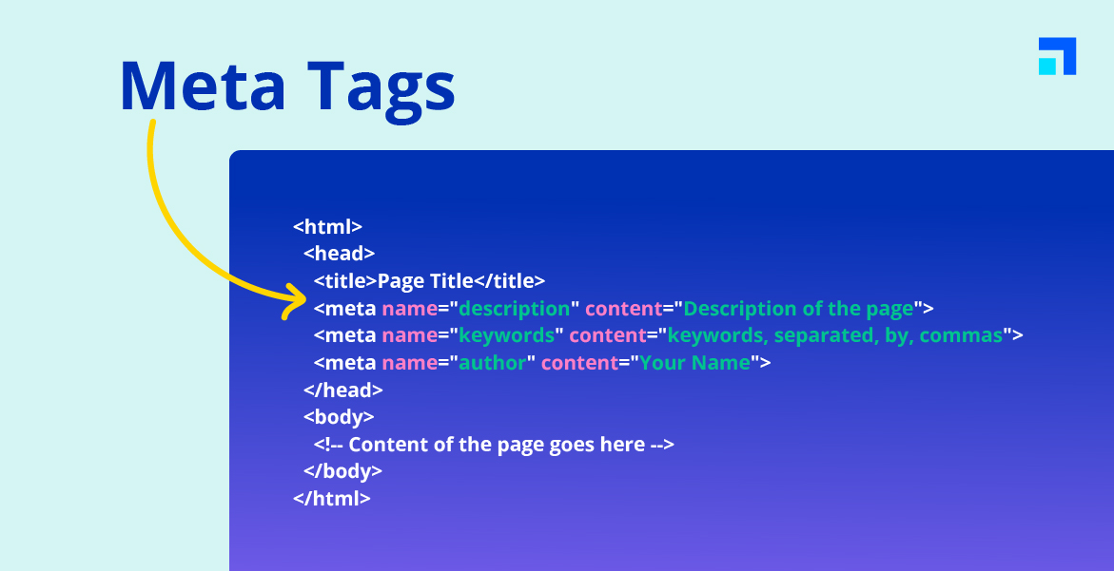
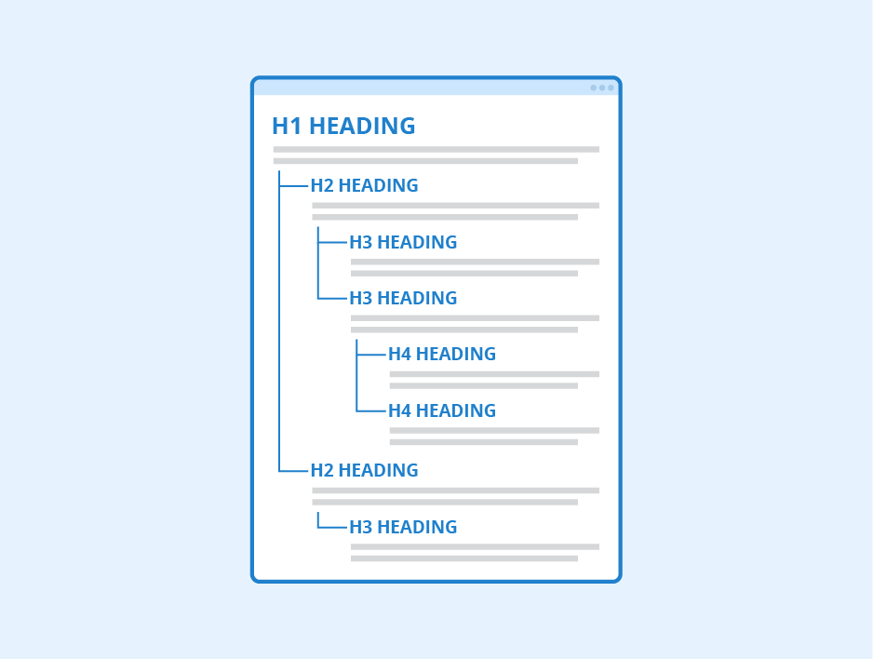
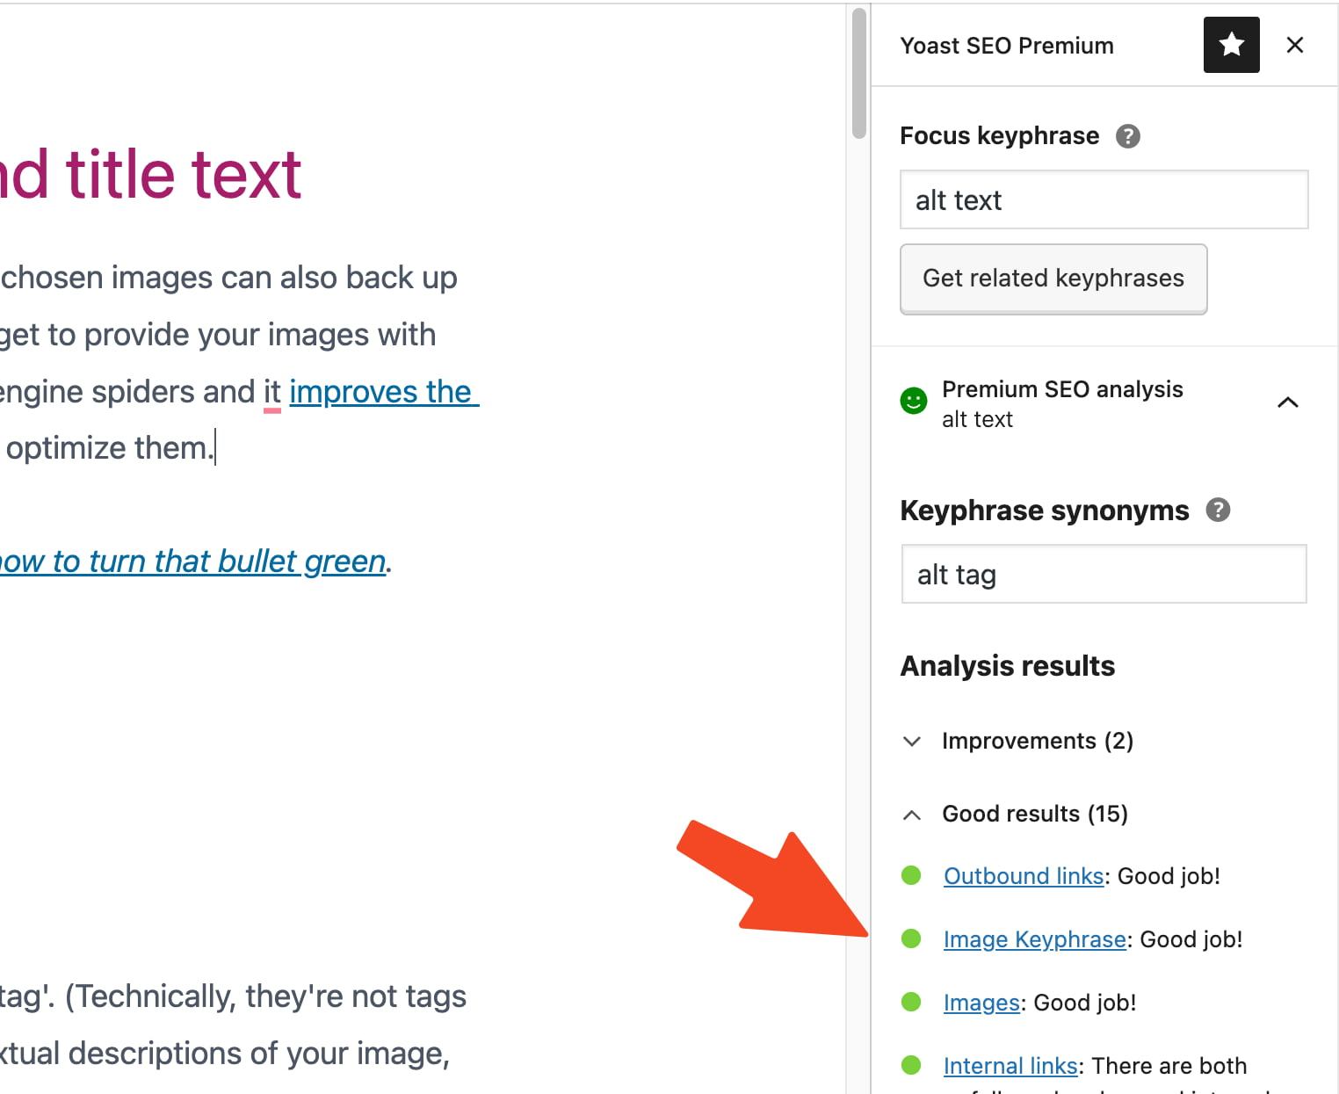
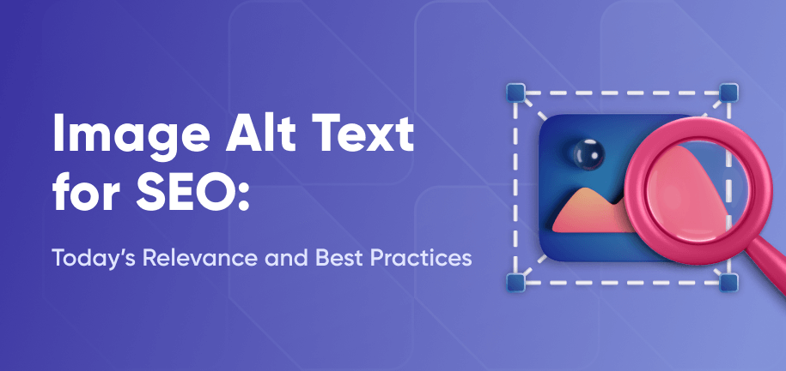
SEO (Search Engine Optimization) helps websites rank higher on Google.

🔹 Meta Description
<meta name="description" content="Best HTML tutorial">
✔ Appears in Google results
✔ Improves click-through rate

🔹 Title Optimization
<title>Learn HTML for Beginners</title>
✔ One title per page
✔ 50–60 characters ideal

🔹 Heading Hierarchy
<h1>Main</h1>
<h2>Sub</h2>
<h3>Child</h3>
✔ Logical order
✔ SEO + accessibility

🔹 Image Alt Tags
<img src="html.png" alt="HTML logo">
📌 Search engines cannot see images — they read ALT text.

2️⃣9️⃣ HTML BEST PRACTICES ✅
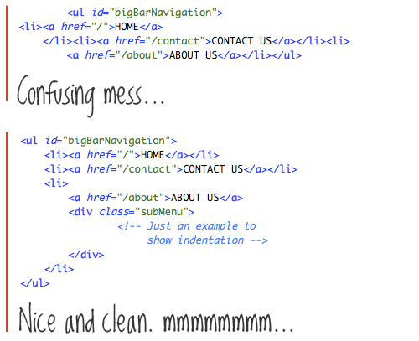
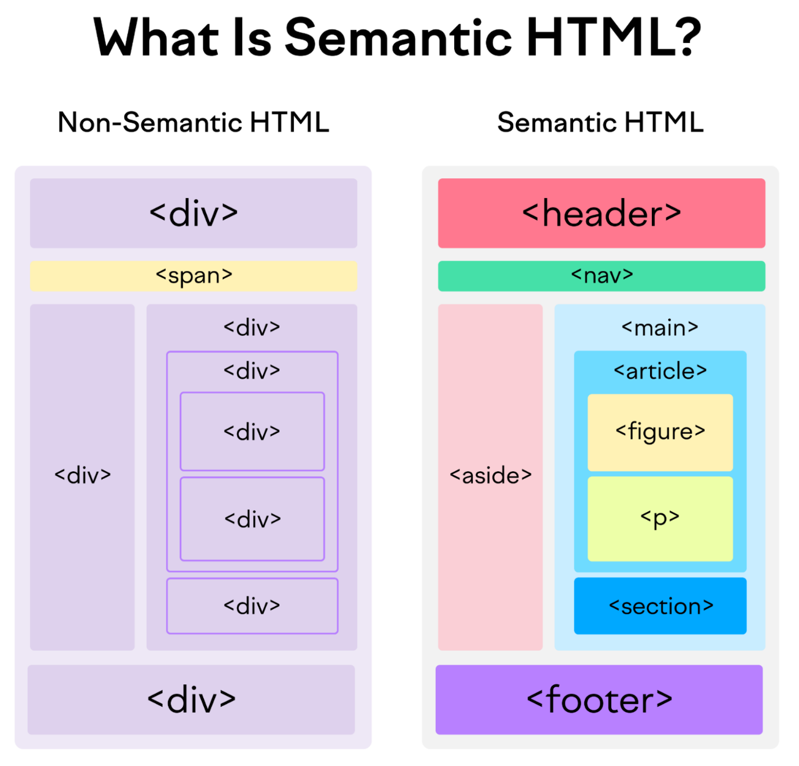
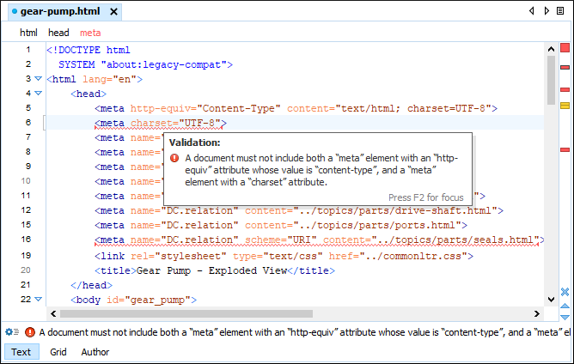
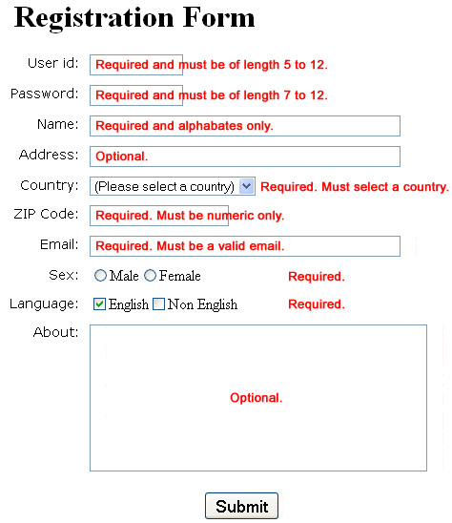
Best practices make your code professional, readable, and scalable.

🔹 Key Best Practices
✔ Clean indentation
✔ Semantic tags
✔ External CSS
✔ External JS
✔ Valid HTML

🔹 Bad vs Good
❌ Bad
<p style="color:red;">Text</p>
✅ Good
<p class="text">Text</p>
📌 Interview Line:
Readable code is more important than clever code.

3️⃣0️⃣ HTML ADVANCED / INTERVIEW TOPICS 🔥
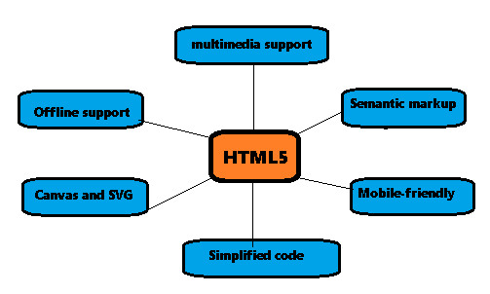
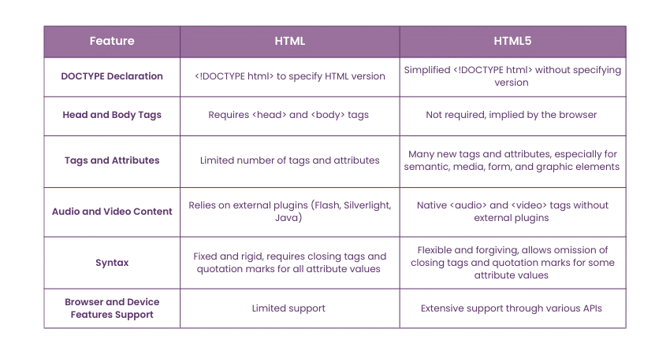
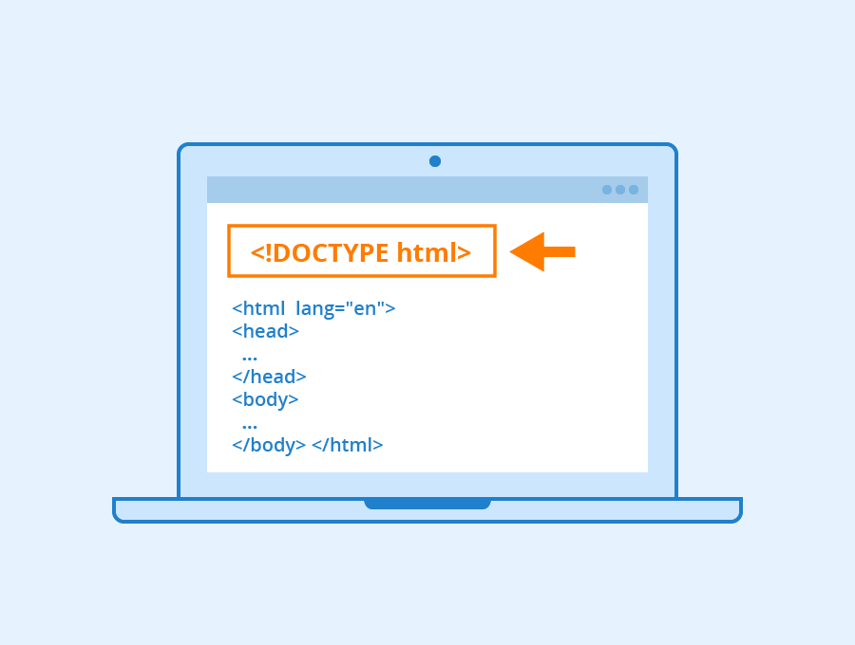
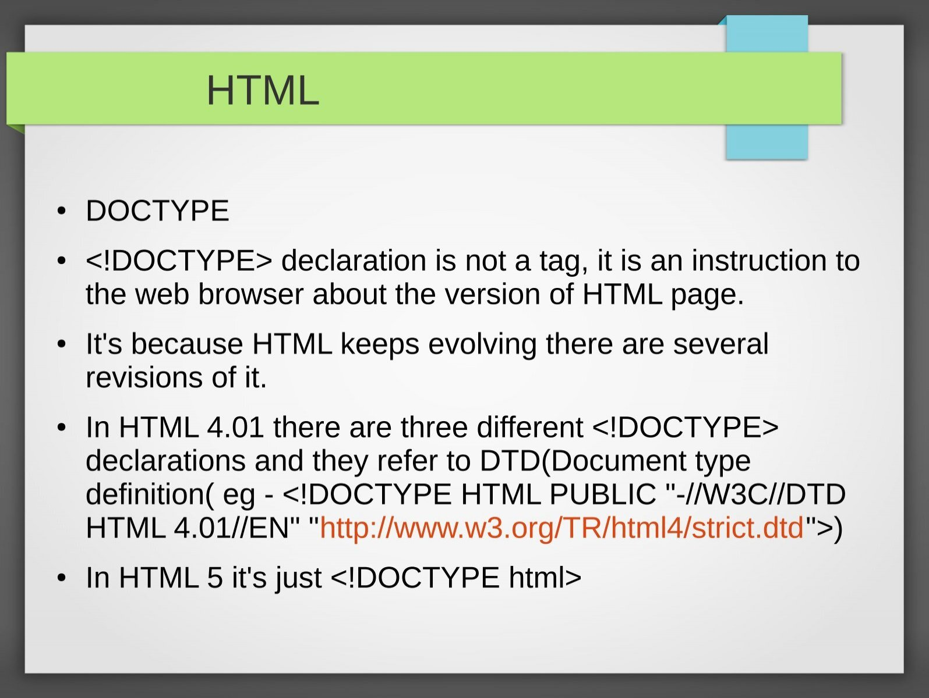
These topics are frequently asked in interviews.

🔹 HTML5 Features
✔ Audio & Video
✔ Semantic elements
✔ Canvas & SVG
✔ Local storage

🔹 HTML vs HTML5
HTML | HTML5
No media support | Audio & video
No semantics | Semantic tags
Plugins required | Native features

🔹 Doctype Importance
<!DOCTYPE html>
✔ Enables standards mode
✔ Prevents browser quirks

🔹 Void Elements
Tags without closing tag:
<img> <br> <hr> <meta>

🔹 Data Attributes
<button data-id="101">Click</button>
✔ Store custom data
✔ Used by JS

🔹 Canvas & SVG
<canvas></canvas>
<svg></svg>
✔ Canvas → bitmap graphics
✔ SVG → scalable vector graphics
📌 Interview Line:
SVG is resolution-independent, Canvas is pixel-based.

